Charles Henderson

Reuel Maddela

Harpreet Sidhu

Activity 10 – Builds from Activity 6 & 3

NLog text file with failed and passed login attempts:

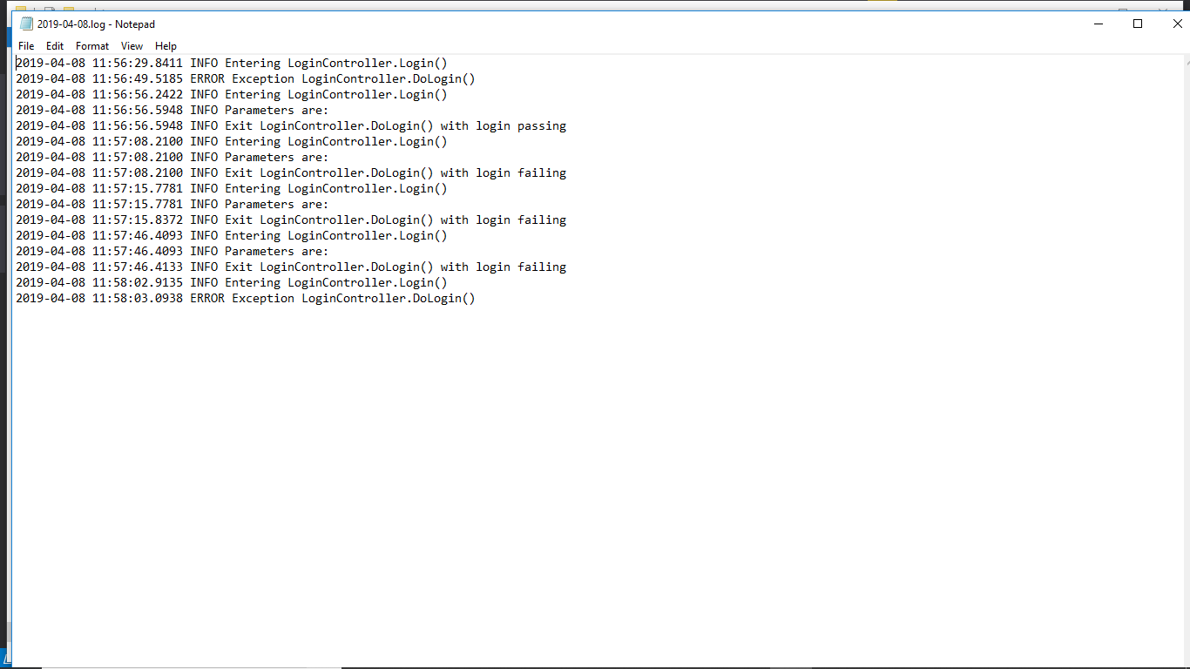Initialization of MyLogger1 class: 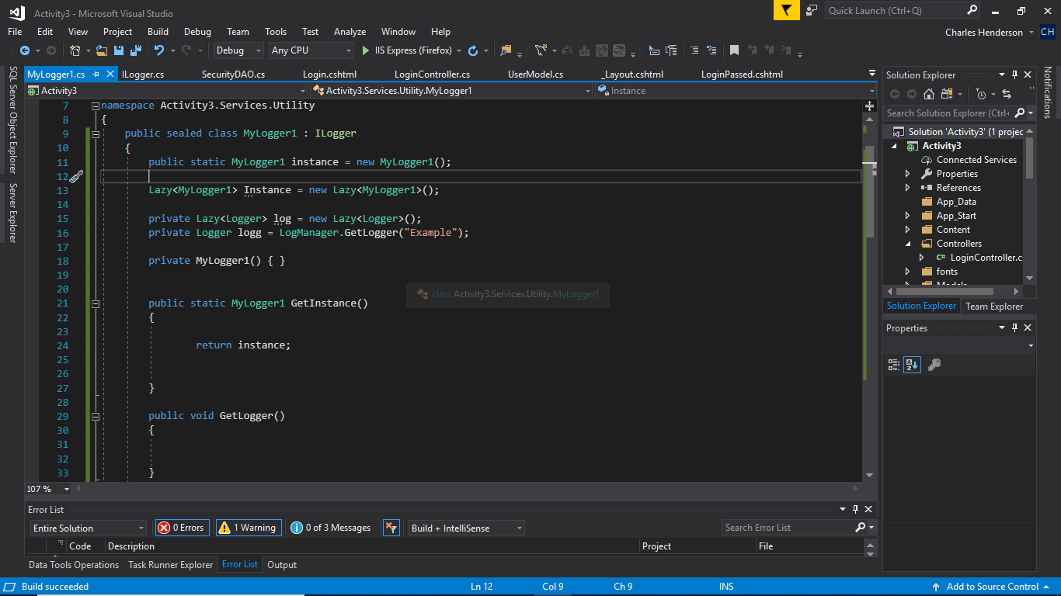

Some of the methods implemented from Interface

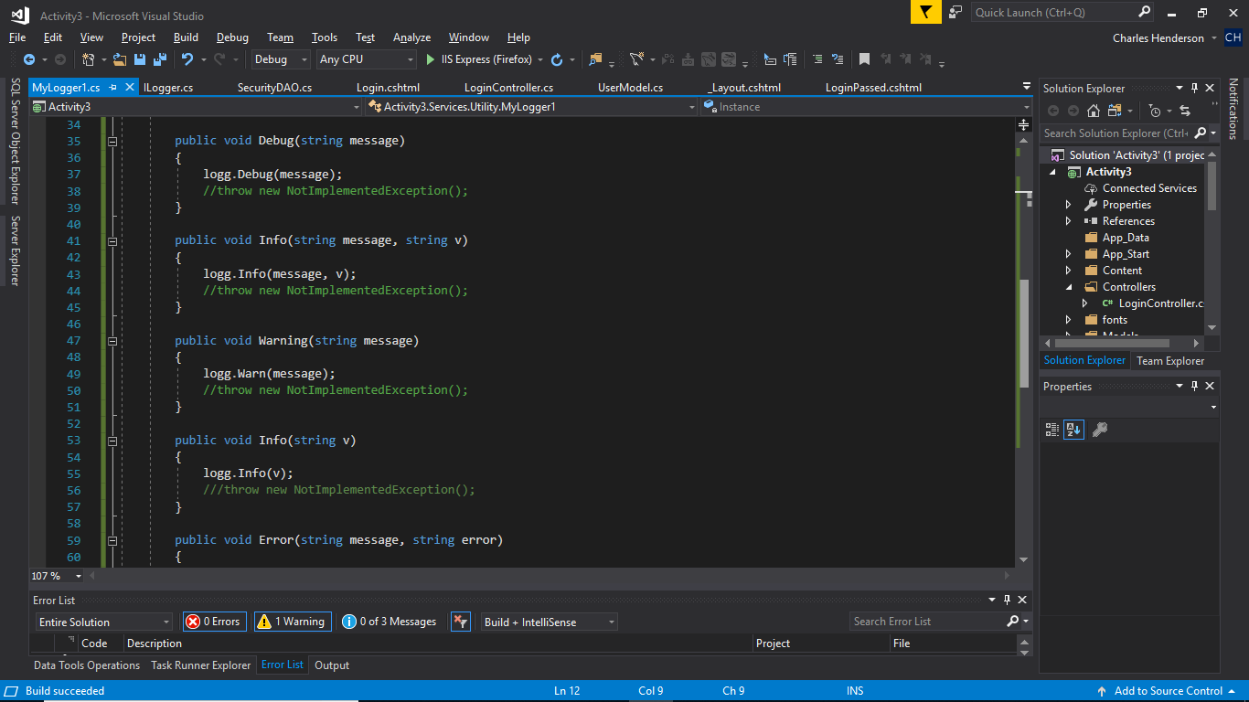

Config for MyLogger1 Nlog.info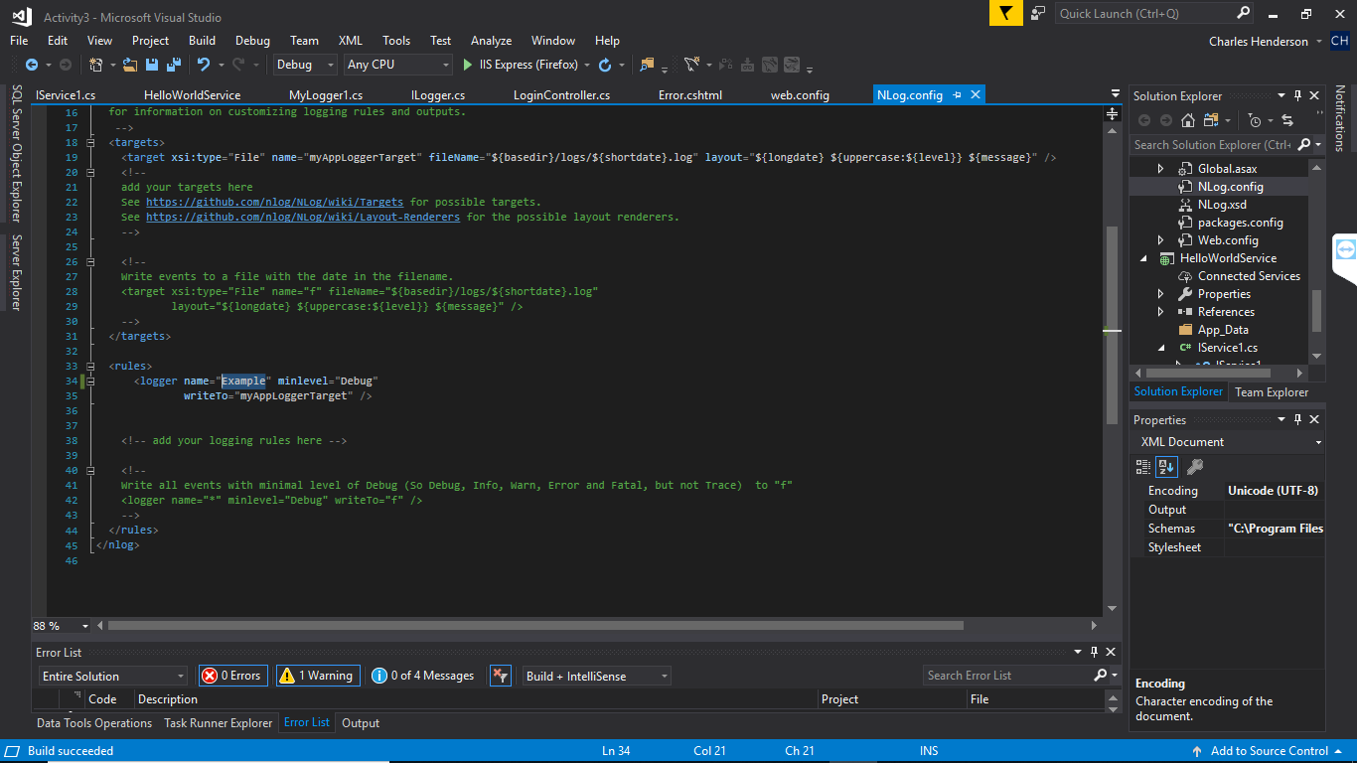

Example created in MyLogger: 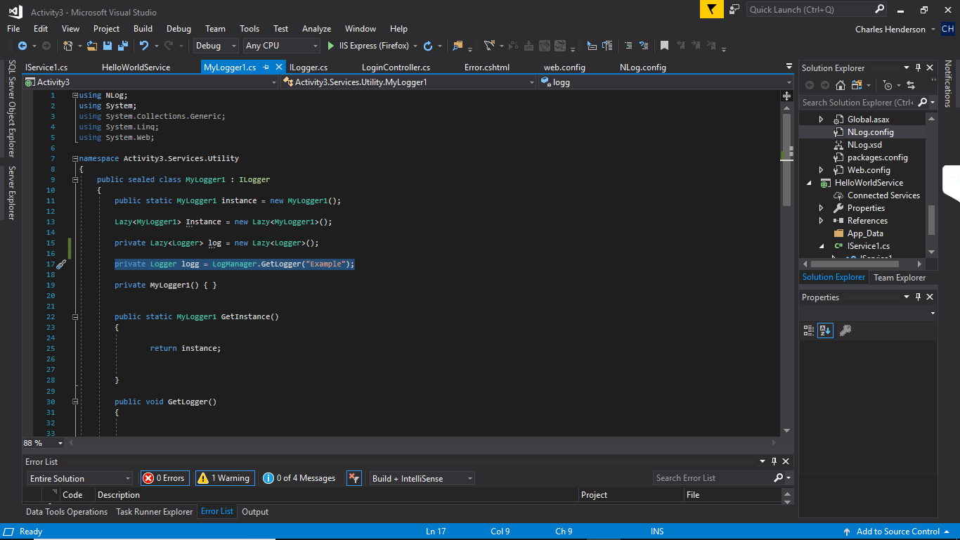

Resulting Log file:

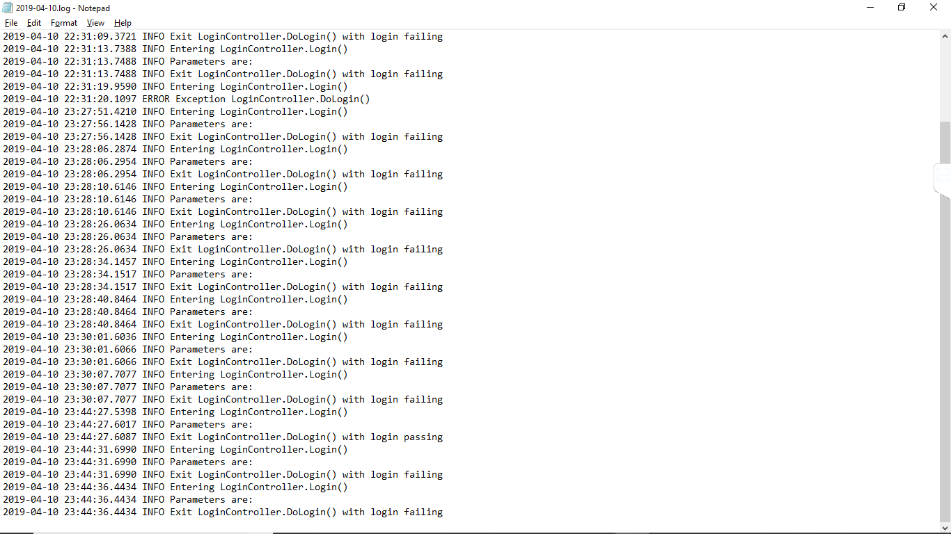

These projects are too large and can’t be uploaded to loudcloud, so the code can be accessed from:

https://github.com/agingdanger/CST-247